Tackbrev från NR i Tyskland och Belgien

Dear National Representative Ewa Jägevall,
Thank you so much for your words, wishes and support. That feels good.
I thank Inner Wheel Sweden.
Best wishes
Dorothée
Dorothée Remmler-Bellen
National Representative 2021/22
IW Germany

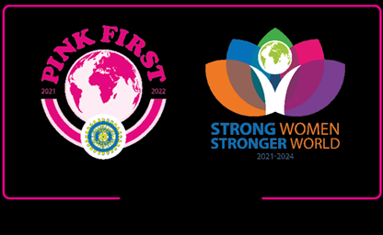

Dear Ewa,
On behalf of all our IW members of Belgium-Luxembourg I thank you so much for your concerning.
My DC's had contact with all the clubs in the affected area and we're lucky none of our members were victimized.
A lot of clubs started already to give support to the people in need.
Warm regards.
In IW friendship,
Paulette Dewinter – De Soete
President of Council & National Representative
IW Belgium-Luxembourg 2020-22

