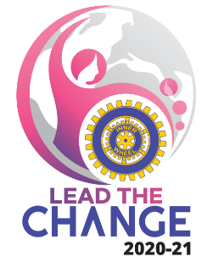 Date : November 10, 2020
Dr Bina Vyas
President
International Inner Wheel

Dear Change Maker Presidents
We have all heard and read that “ Time and Tide wait for no man “.
4 months of the year – LEAD THE CHANGE – have gone by.
We have only 365 days at our disposal. Let us not allow it to pass by… because this time will never come back to us.
Someone has rightly said … “ I expect to pass through this world but once. Any good thing, therefore, that I can do or any kindness that I can show to any fellow creature, let me do it now “,,,
Let not the pandemic be our excuse for not performing or achieving our desired Goals of the year.
Please focus and strive to :
- Increase Membership
- Form New Clubs
- Form New Gen Clubs
- Contact and Plan for Virtual Youth Development Programs &
Organise on topics already given in Goal with the help of
An expert in your town.
It is very much possible to organise Virtual Programs.
Friends,,,, let us complete as many Goals as possible in the year.
Let us face these challenging times and continue our efforts to achieve our challenging Goals.
I wish you the very best in your endeavours as you LEAD THE CHANGE for a better Inner Wheel world.
Lots of love & Best Wishes
Bina
Bina Vyas

