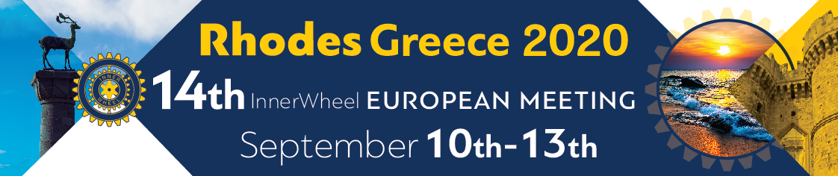

14th INNER WHEEL EUROPEAN MEETING in RHODES, GREECE
September 10th to 13th , 2020

REGISTRATION FORM

Name of IW member:

…………………………………………………………………………………………..

Function: …………………………………………………………………………………………

Country: ………………………………………………………………………………………

Name of accompanying partner:

………………………………………………………….…………………...

I/wewill attend the European Meeting in Rhodes and will transfer in Euro:

EUR: 360 Delegate Registration Fee
EUR: 360 Partner Registration Fee

 | Delegate | Partner
Delegate Fee
Partner Fee
Dietary requirements

PAYMENT for Delegate Fee and Partner Fee
Please transfer your Delegate’s Registration and your Partner’s Fee by May 30th 2020 at latest to
• IBAN: GR21 0171 3190 0063 1914 2106 432
• SWIFT/BIC: PIRBGRAA
• Account Holder: 12703293 AVGERINOU ATHANASIA
• Reason for payment: European Meeting 2020
Or
IBAN: GR6701100510000005177086534
SWIFT/BIC: ETHNGRAA
Account Holder: FALIDAS A, PAPADOPOULOU A
Please don’t hesitate to contact us if you have any questions.

For the registration payments, please make sure that all costs are paid by your bank in euros.

Thank you for emailing the registration form
No later than July 31st, 2020 to
Sissy Angerinou
sissy-avgerinou@hotmail.com

