Swedish Inner Wheel

Dear Madame President,

My name is Ingelög Wyndhamn and I am the National Representative of the Swedish Inner Wheel .
I have the great pleasure to invite you to a Friendship Meeting from the 4th to the 6th of September 2020 in Tällberg, Sweden on behalf of the Swedish Inner Wheel Council and the Swedish club members. It would be a great honour for us if you could come and visit us.

Friendship Meetings take place every third year and this time it is district 233 that is the hostess. All club members in Sweden are also invited to take part in this meeting and it is an opportunity to meet, exchange ideas, listen to speakers, make outings, get to know the area and enjoy ourselves.

Here follows a very short presentation in words and pictures of this part of Sweden.
Tällberg is situated in 1. the county of Dalarna, known for its beautiful nature, forests and lakes. It is also known for 2. Dalahästarna, wooden painted horses, 3. Carl Larsson, painter from the 19th -20th century who epitomises the idyllic nature and family life for every Swede. 4. Anders Zorn, another painter known for his portraits of famous people and women from Dalarna, 5. Erik Axel Karlfeldt, a Nobel Laureate poet 6. Dr Munthe , physician who lived in Capri, 7.Dalhalla, an open-air scene in a former mine and there are many more things.
1. 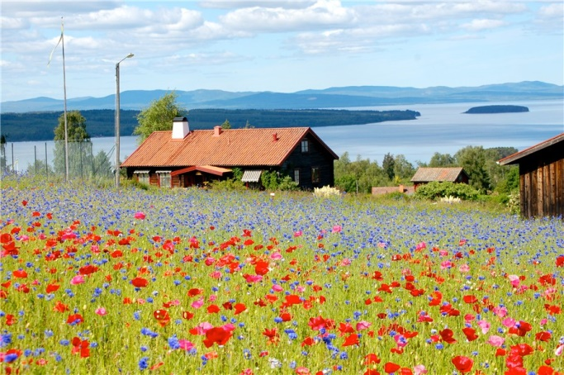 2. 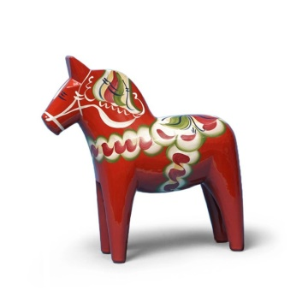
3.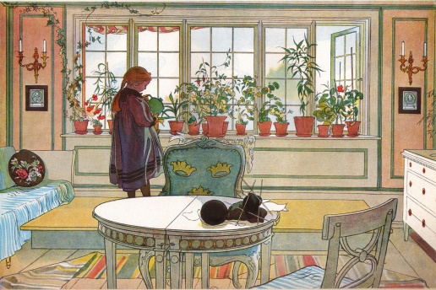 4.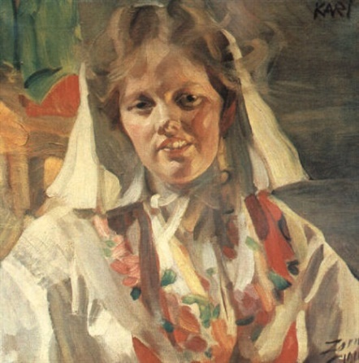

5. 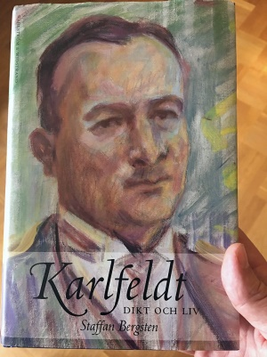 6. 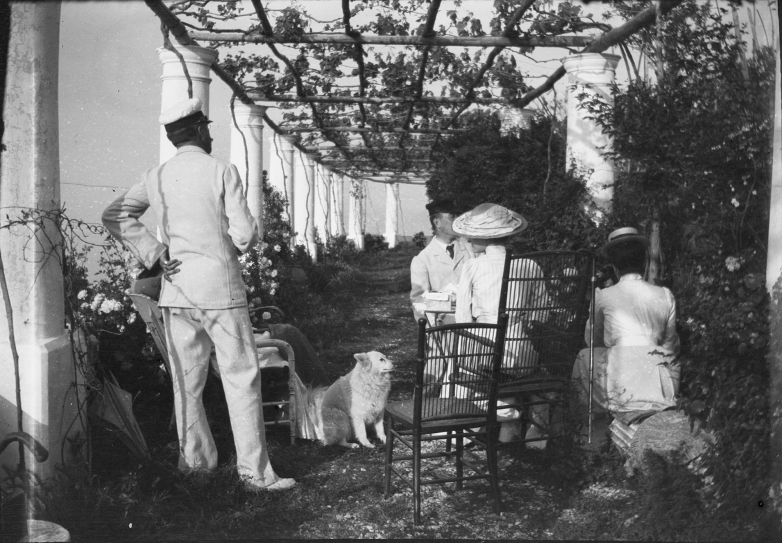

7. 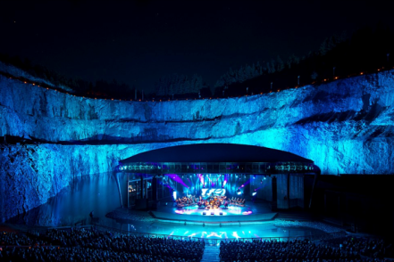

We hope that a visit from our International President will be possible. It would be an excellent opportunity for our members to meet our IIW President and to get to know our worldwide organisation from another perspective.
Once again, very welcome to our Friendship Meeting in September 2020.
In friendship
Yours sincerely
Ingelög Wyndhamn
National Representative 2018 – 2019.

